Intranasal drug delivery procedure

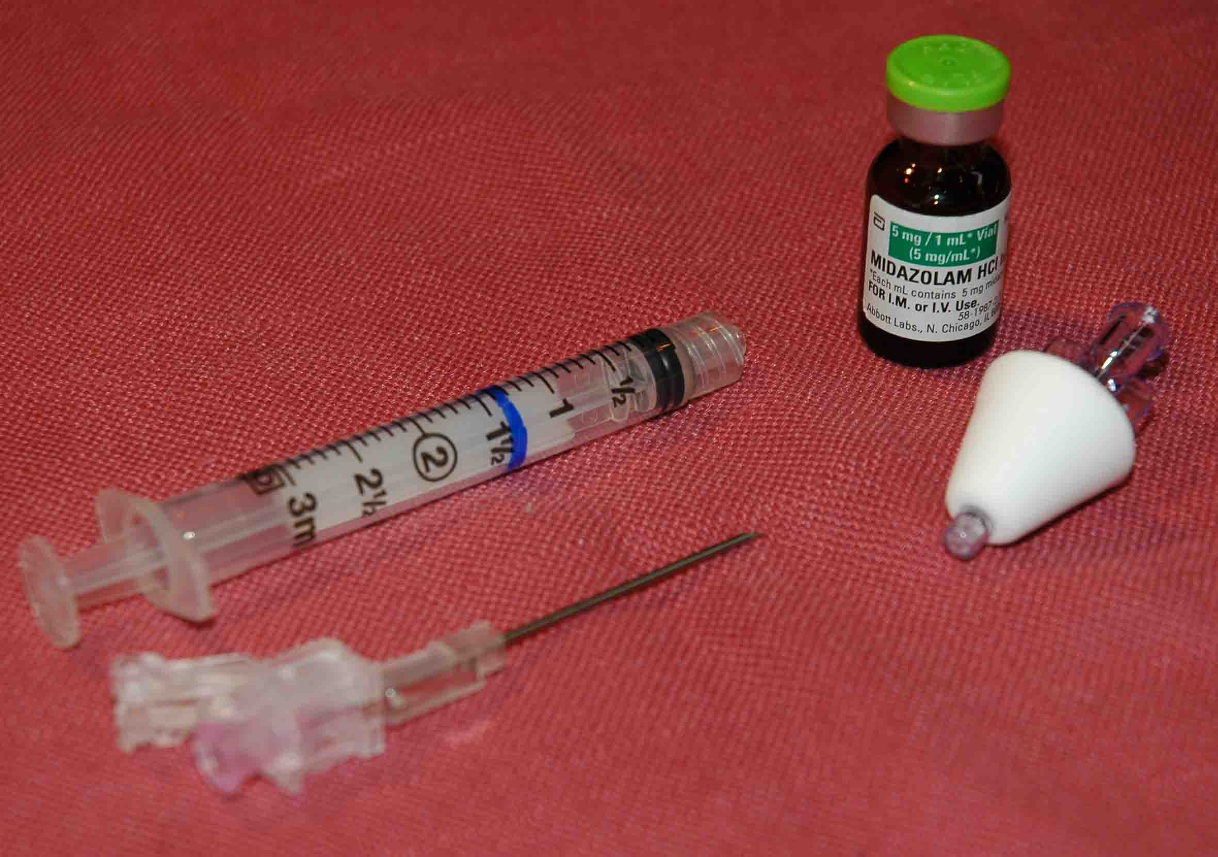
Basic Intranasal Medication
Delivery Materials:

- Syringe and needle/needleless device to draw up the medication
- Atomizer
- Medication of appropriate concentration for nasal medication delivery
  - High concentration - Low volume
  - Ideal volume 0.2 to 0.3 ml per nostril
  - Maximum volume 1 ml per nostril

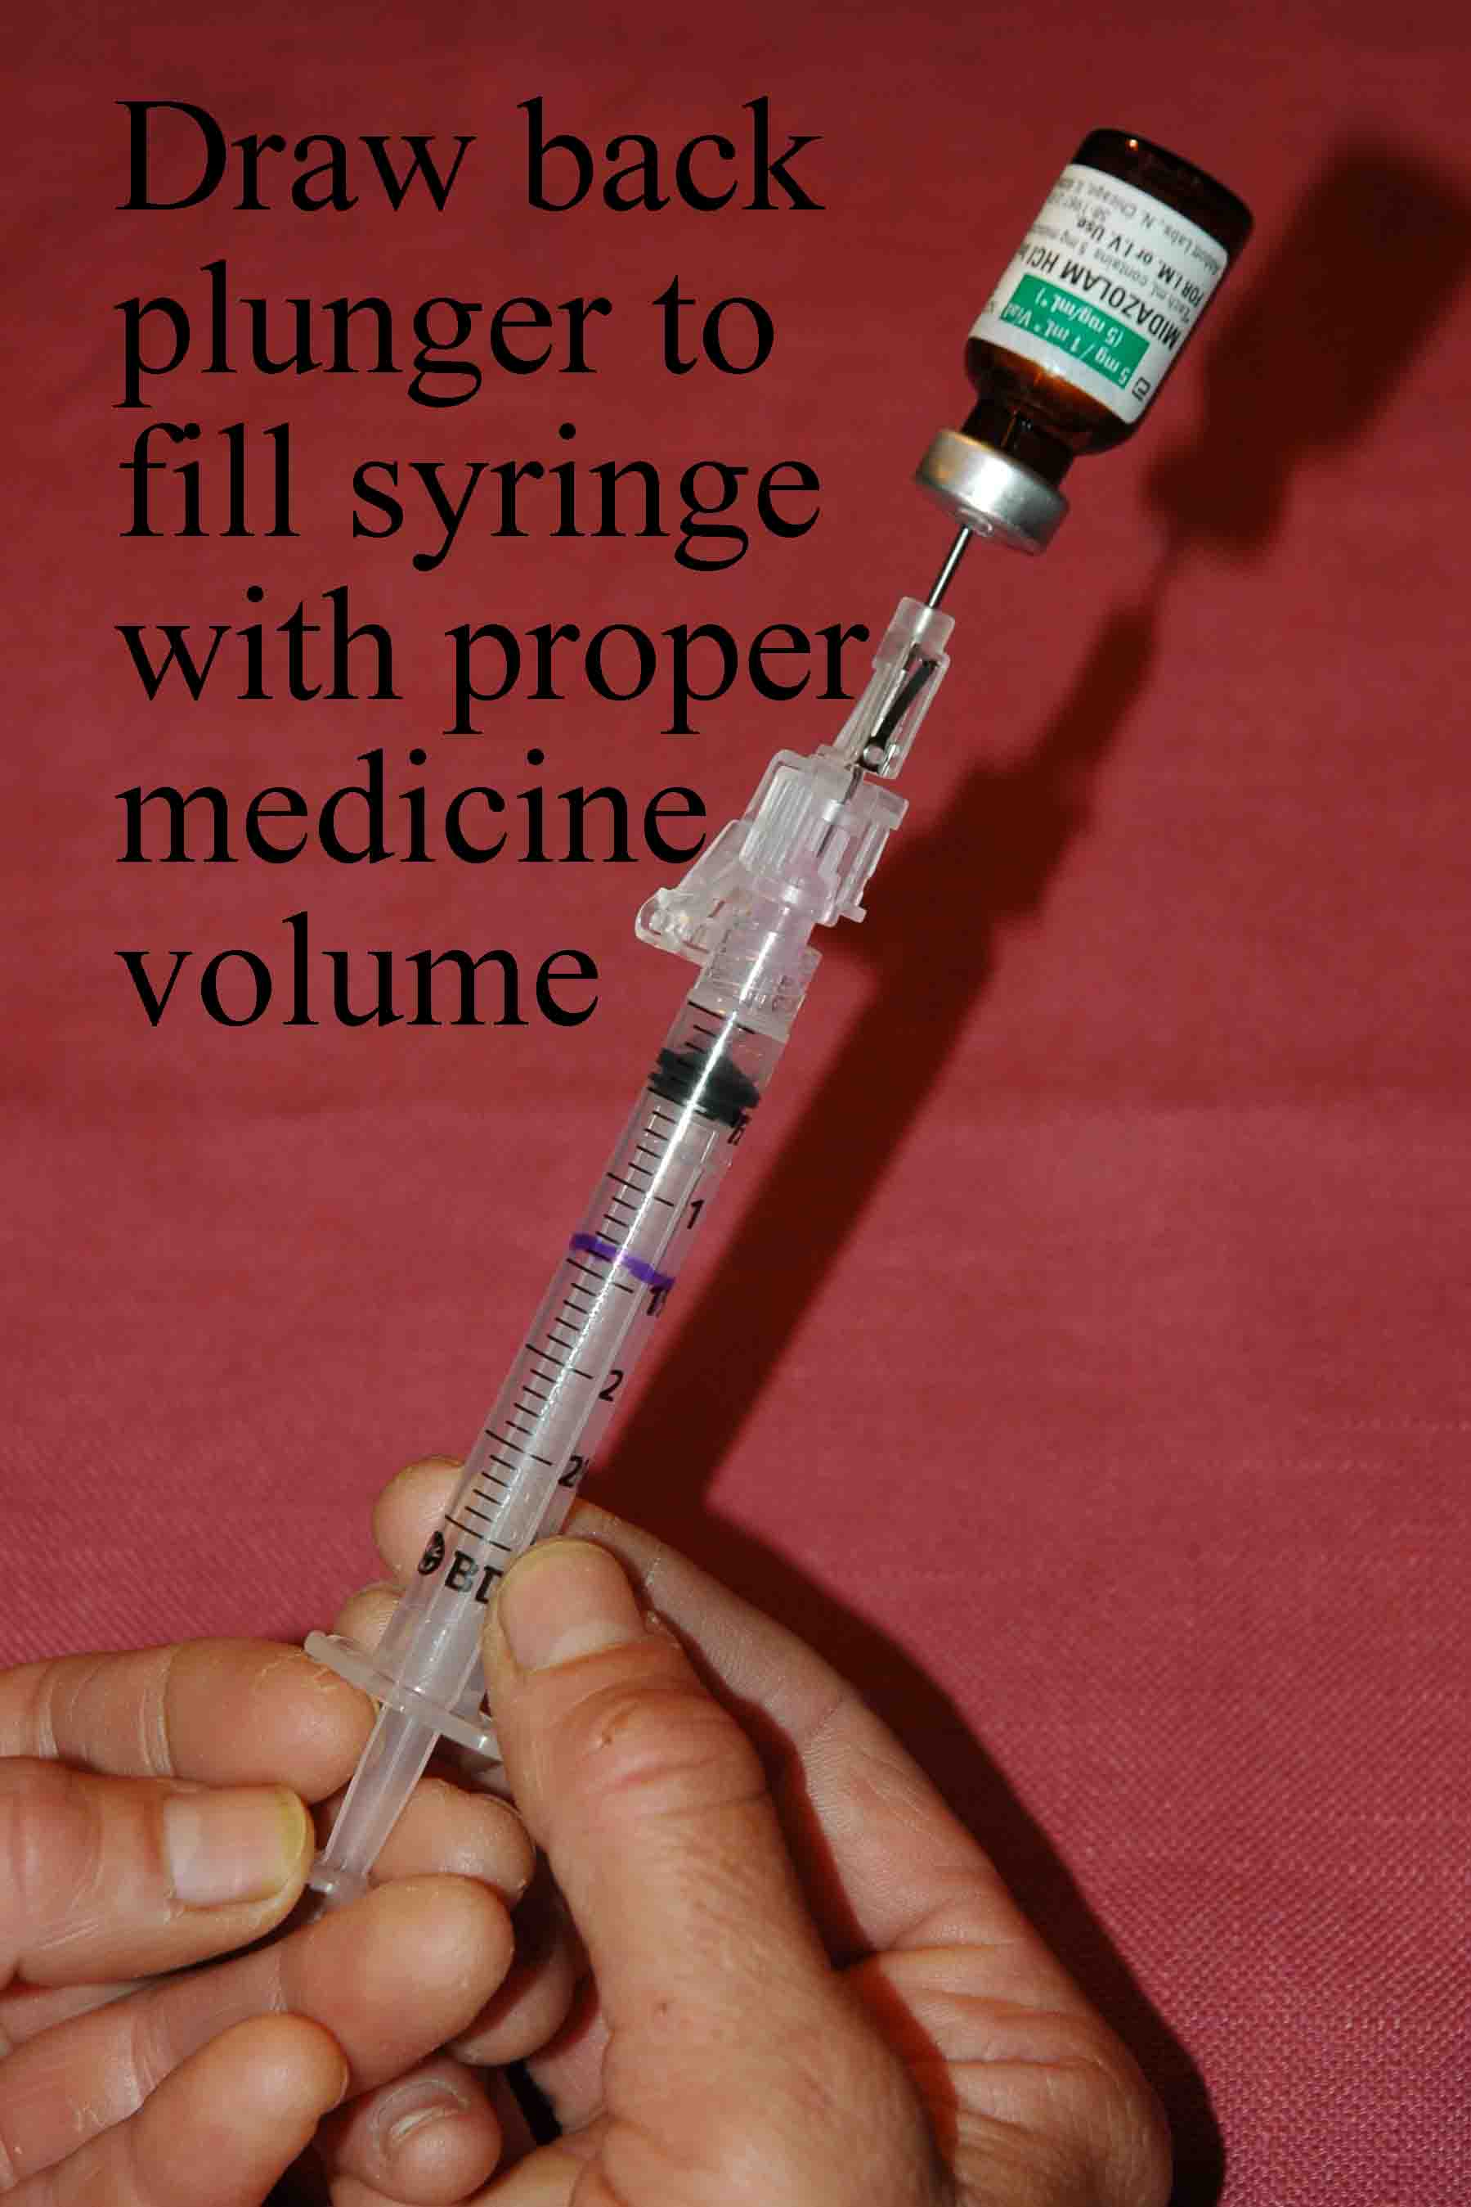
Procedure:

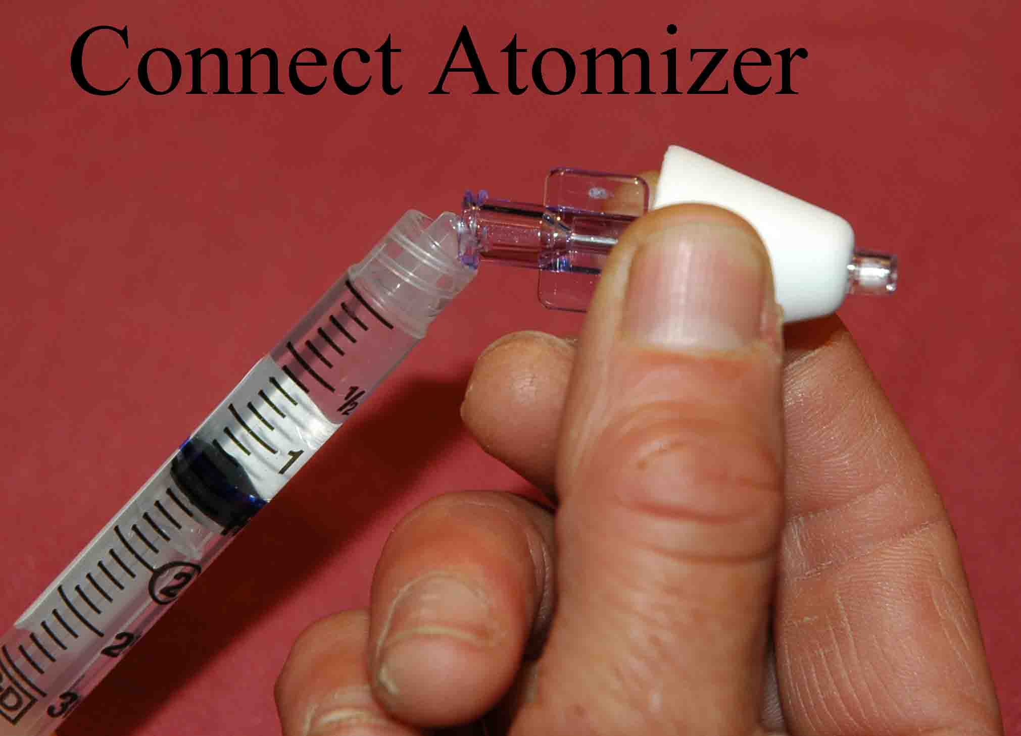
- Aspirate the proper volume of highly concentrated medication required to treat the patient – (an extra 0.1 ml of medication should be drawn up to account for the dead space within the atomizer at the end of the procedure.)

- Twist off/remove the syringe from the needle/needleless device

- Attach the atomizer tip via Luer lock mechanism – it twists into place.
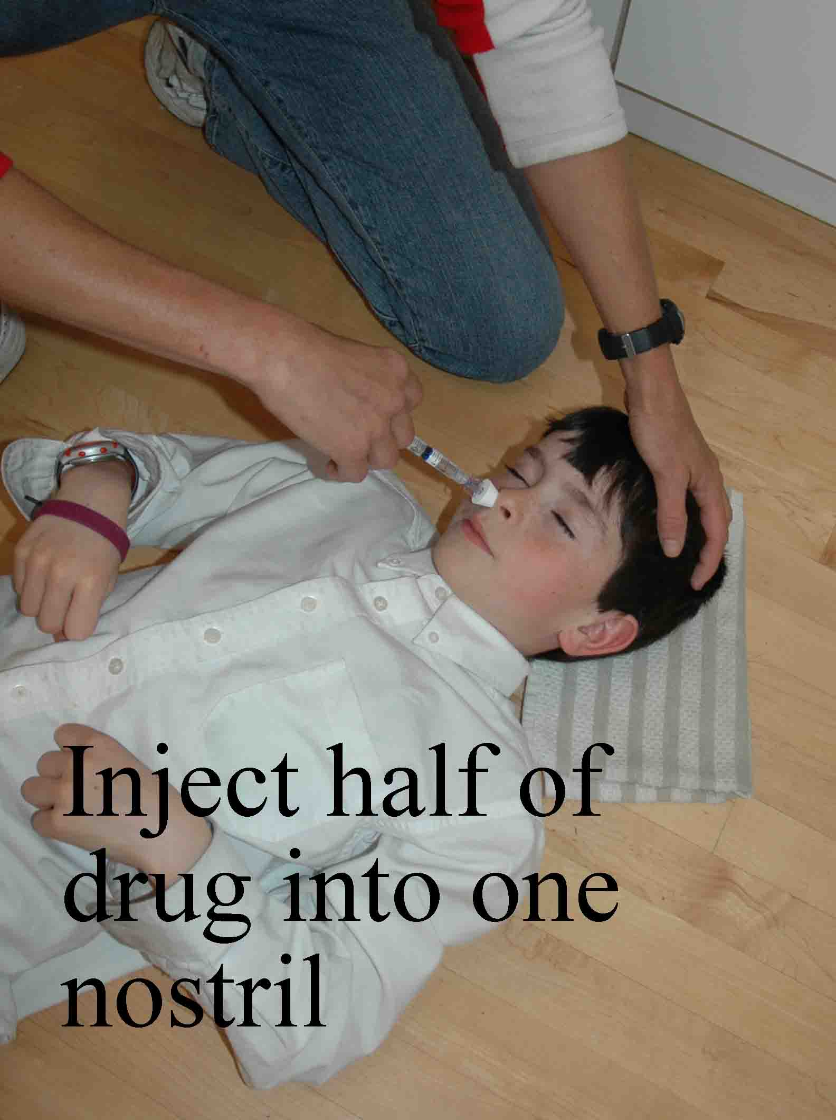
- Slip Luer is also effective as long as the tip is firmly seated on the syringe tip

- Using your free hand to hold the crown of the head stable, place the tip of the atomizer snugly against the nostril aiming slightly up and outward (towards the top of the ear on the same side – this photo in error).
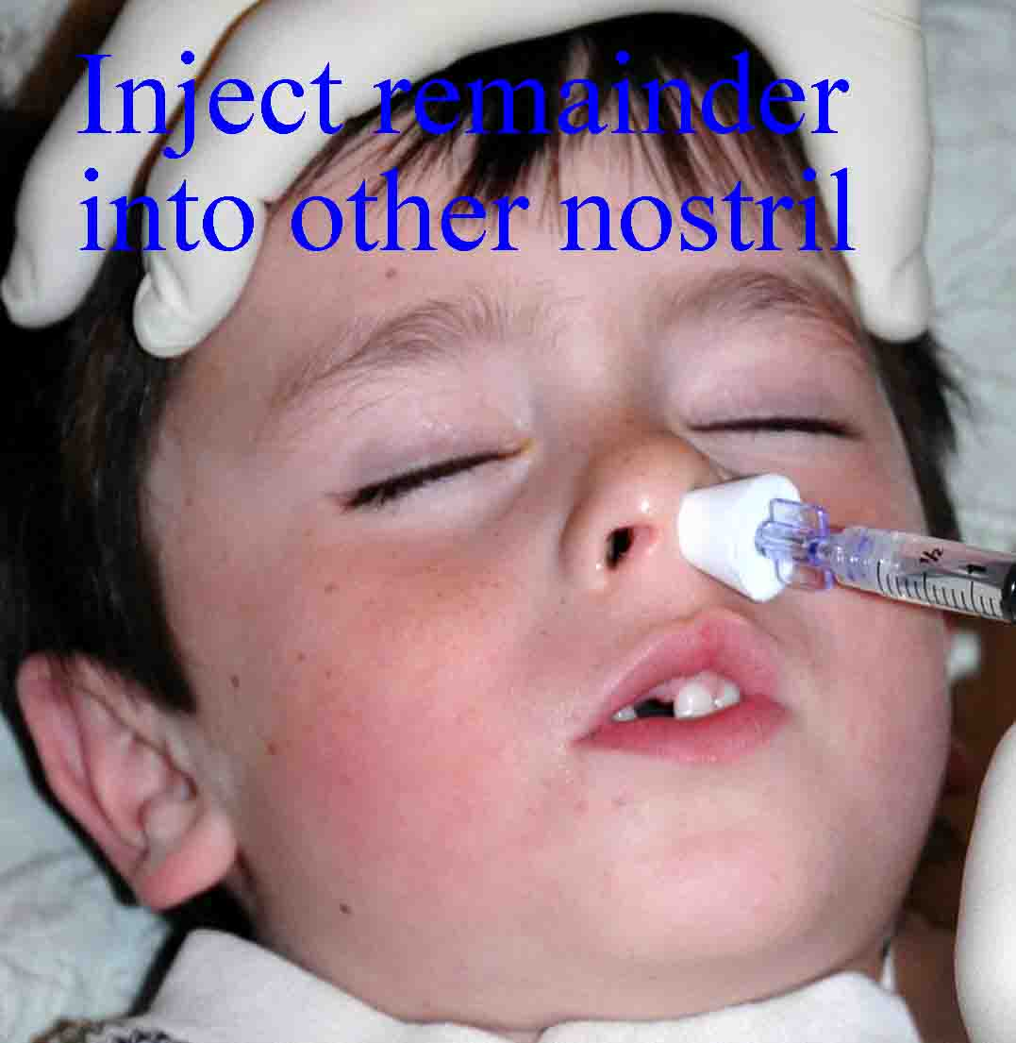
- Briskly compress the syringe plunger to deliver half of the medication into the nostril.

- Move the device over to the opposite nostril and administer the remaining medication into that nostril.

