Epistaxis Treatment Protocol:

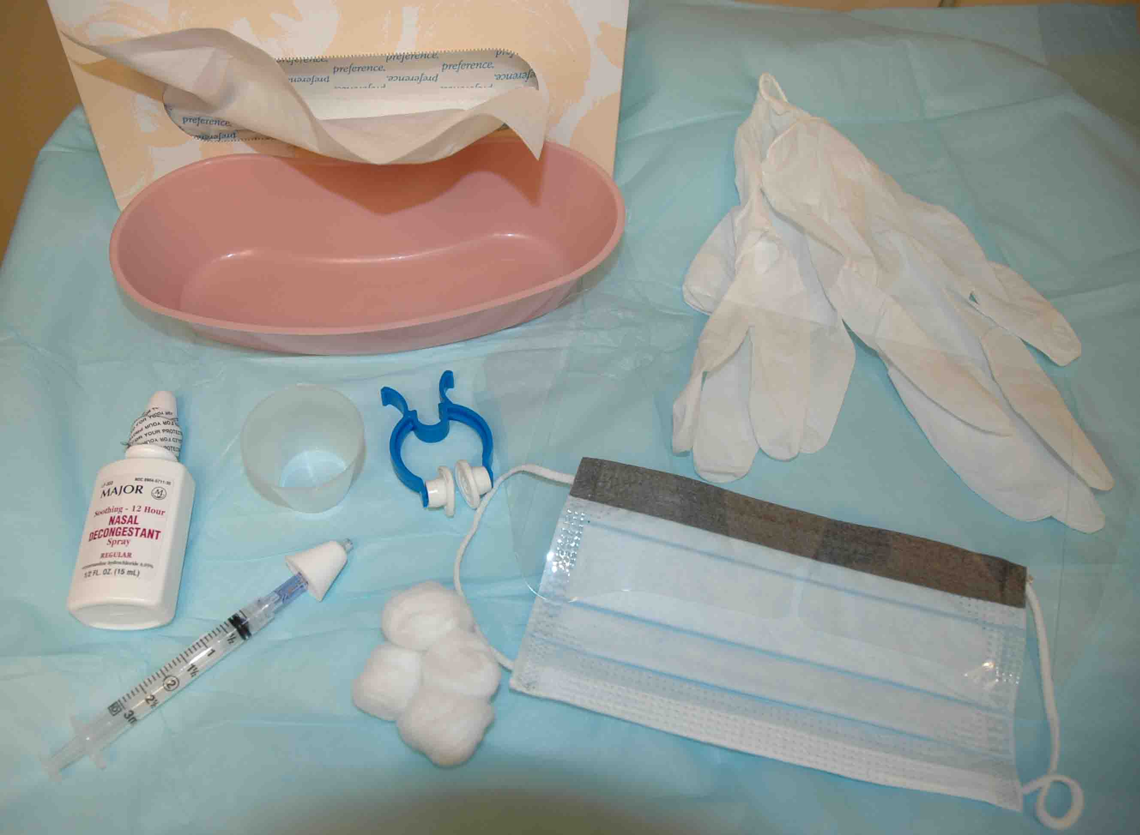
Basic epistaxis tray materials:
- Tissue for patient to blow nose
- Bowl to capture runoff blood
- Gloves and mask for provider
- Cotton balls
- Medication cup
- Oxymetazoline bottle
- 4% lidocaine optional
- Atomizer
- Clamp for nose

Preparation:
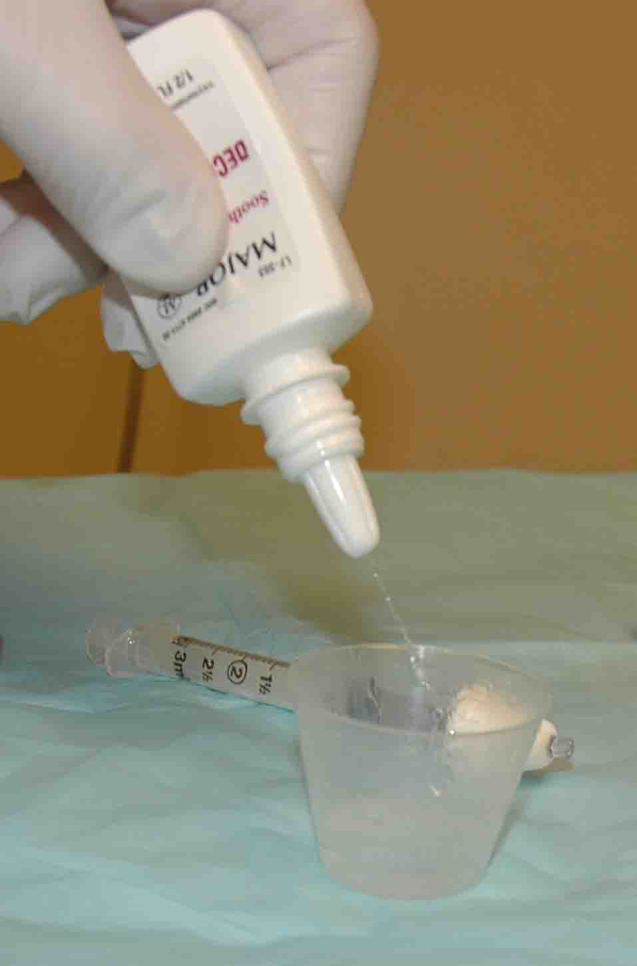
- Provide a gown, tray and tissue paper to the patient to capture the blood.
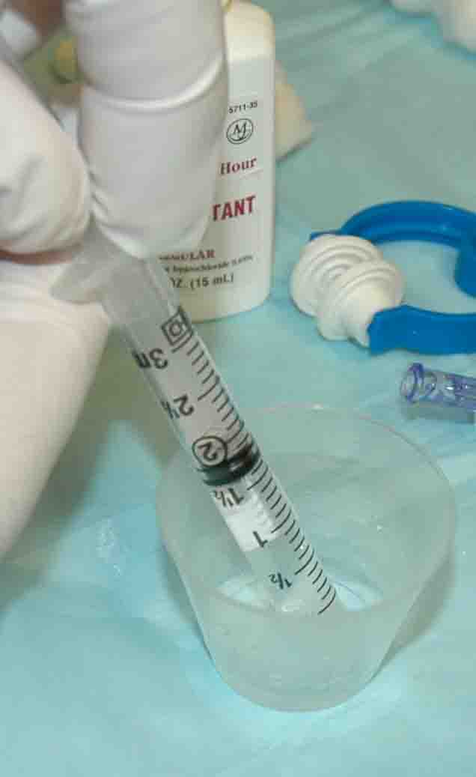
- Squirt oxymetazoline (Afrin) spray into a medication cup so it can be easily drawn into a syringe.

- Draw up 1.0 to 1.5 ml of oxymetazoline (Afrin) into a 3 cc syringe. (Option - Also draw up 0.5 ml of 4% lidocaine into the same syringe for anesthesia n case you need to use cautery).
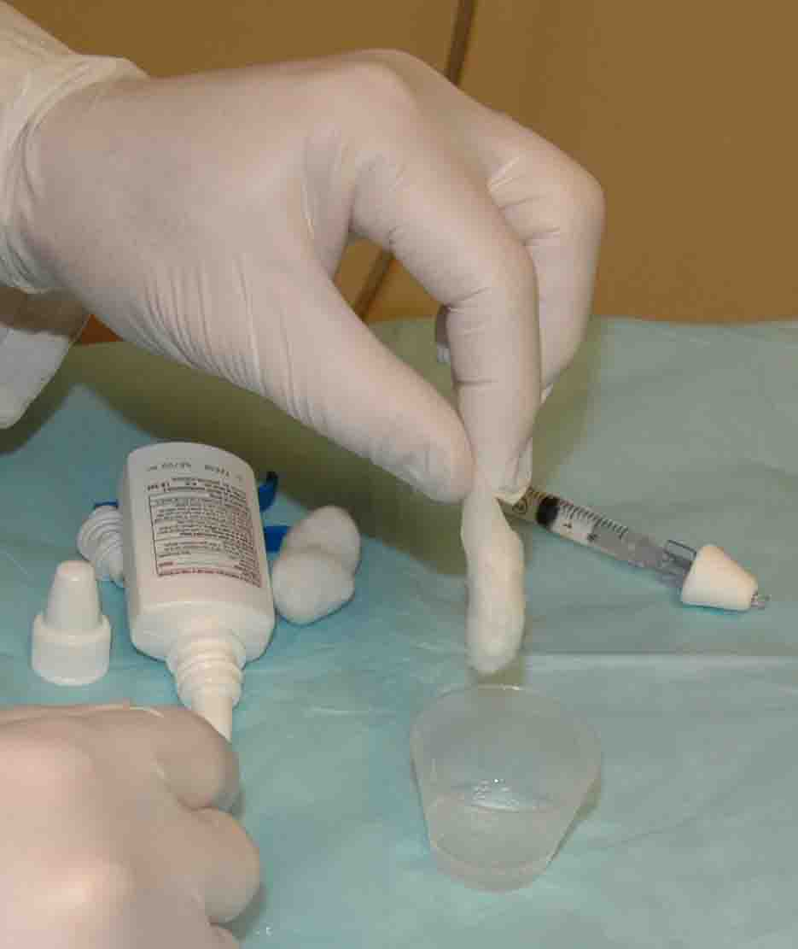
- Connect the syringe to a syringe driven atomizer.
- Put a cotton ball in the remaining oxymetazoline and soak the cotton ball. (double the dose and use two cotton balls if both sides are bleeding)

Procedure:
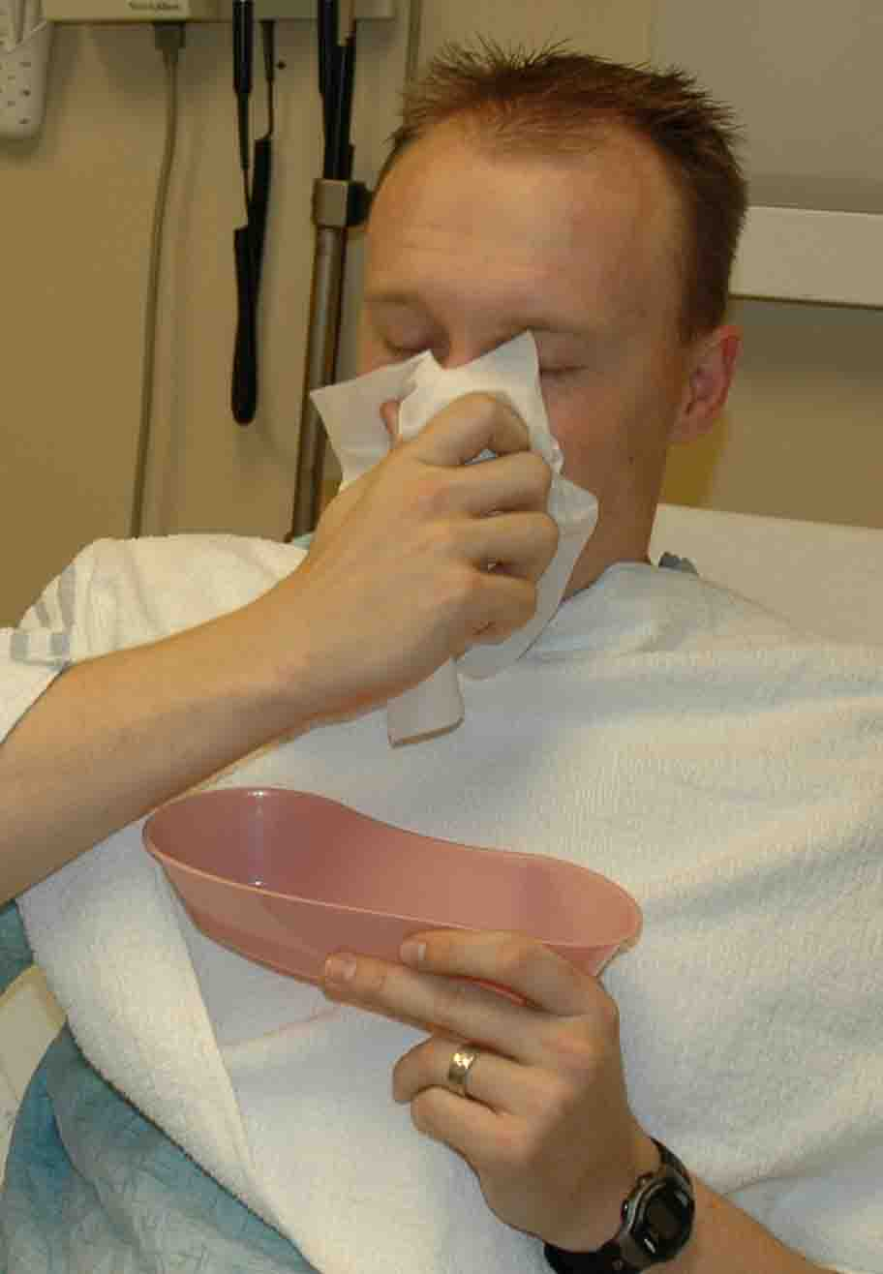
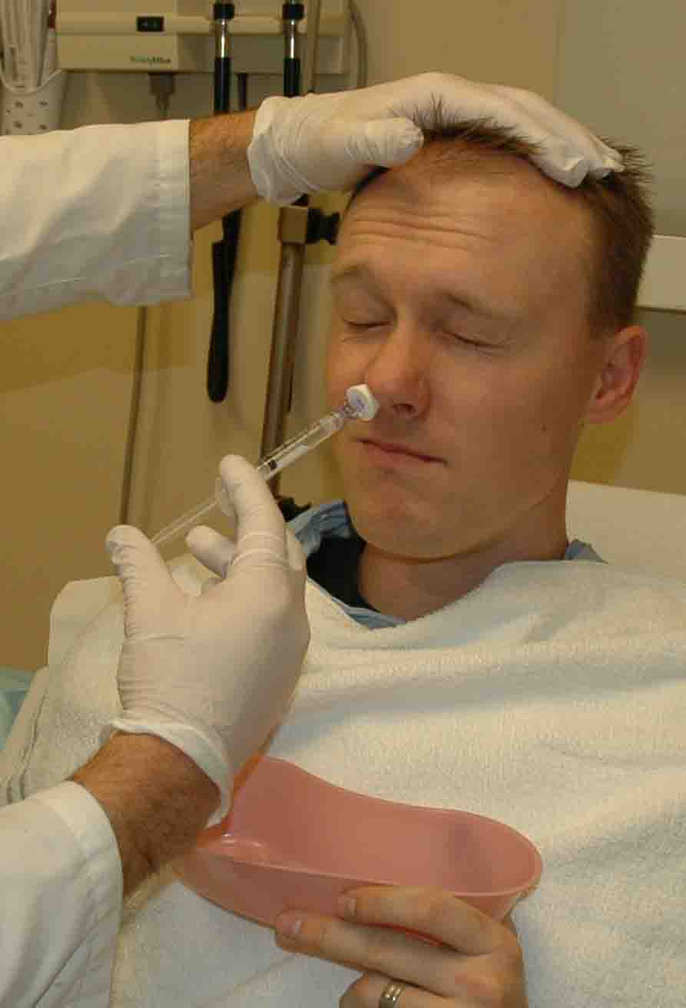
- Ask the patient to blow their nose to clear all the blood clots from the nasal passage. This will clear the nasal cavity and expose the nasal mucosa so the medication is more effective.
- Position the patient approximately 45 degrees recumbent in the bed.
- Place atomizer within the affected nostril.
- Briskly compress syringe to administer 1-1.5 ml of atomized spray into the affected nostril. Ask them to inhale through their nose during the time you spray.
- Allow the patient to capture any runoff blood and solution.
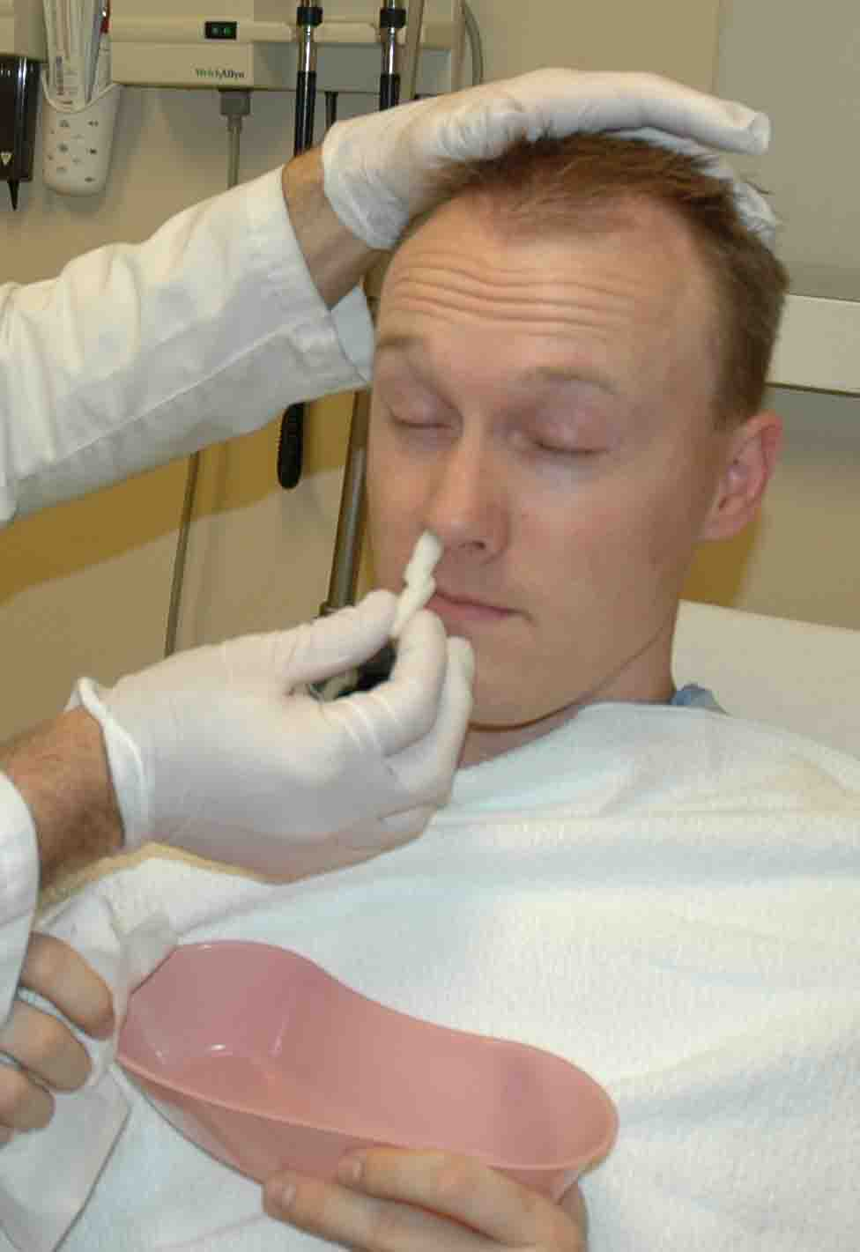
- Take the cotton ball soaked with oxymetazoline and roll into cigarette shape. Place this into the bleeding nostril.
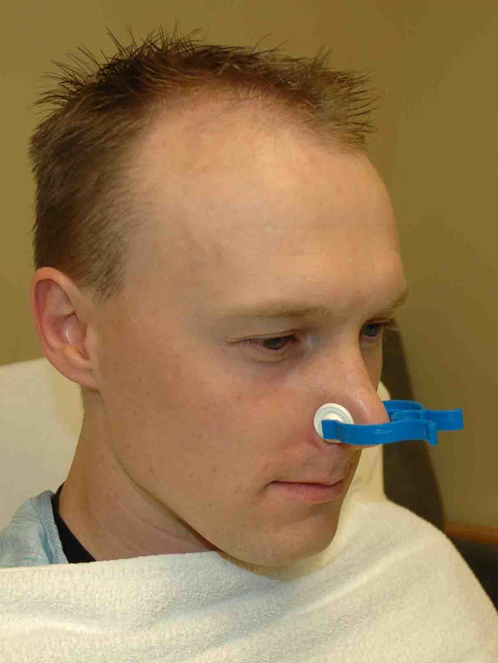
- Repeat in other nostril if it is also bleeding.
- Tape a folded 4X4 across the nose to hold the cotton ball in place and capture blood.
- Sit the patient back up.
- Ask the patient to pinch their nostrils firmly with one hand to reduce blood flow to the anterior nose. Alternatively you can clamp their nose with a pre-made nasal clamp.
- Wait 15 minutes.
- Return, remove the gauze and packing, cauterize any anterior vessels that require cautery (usually not needed).
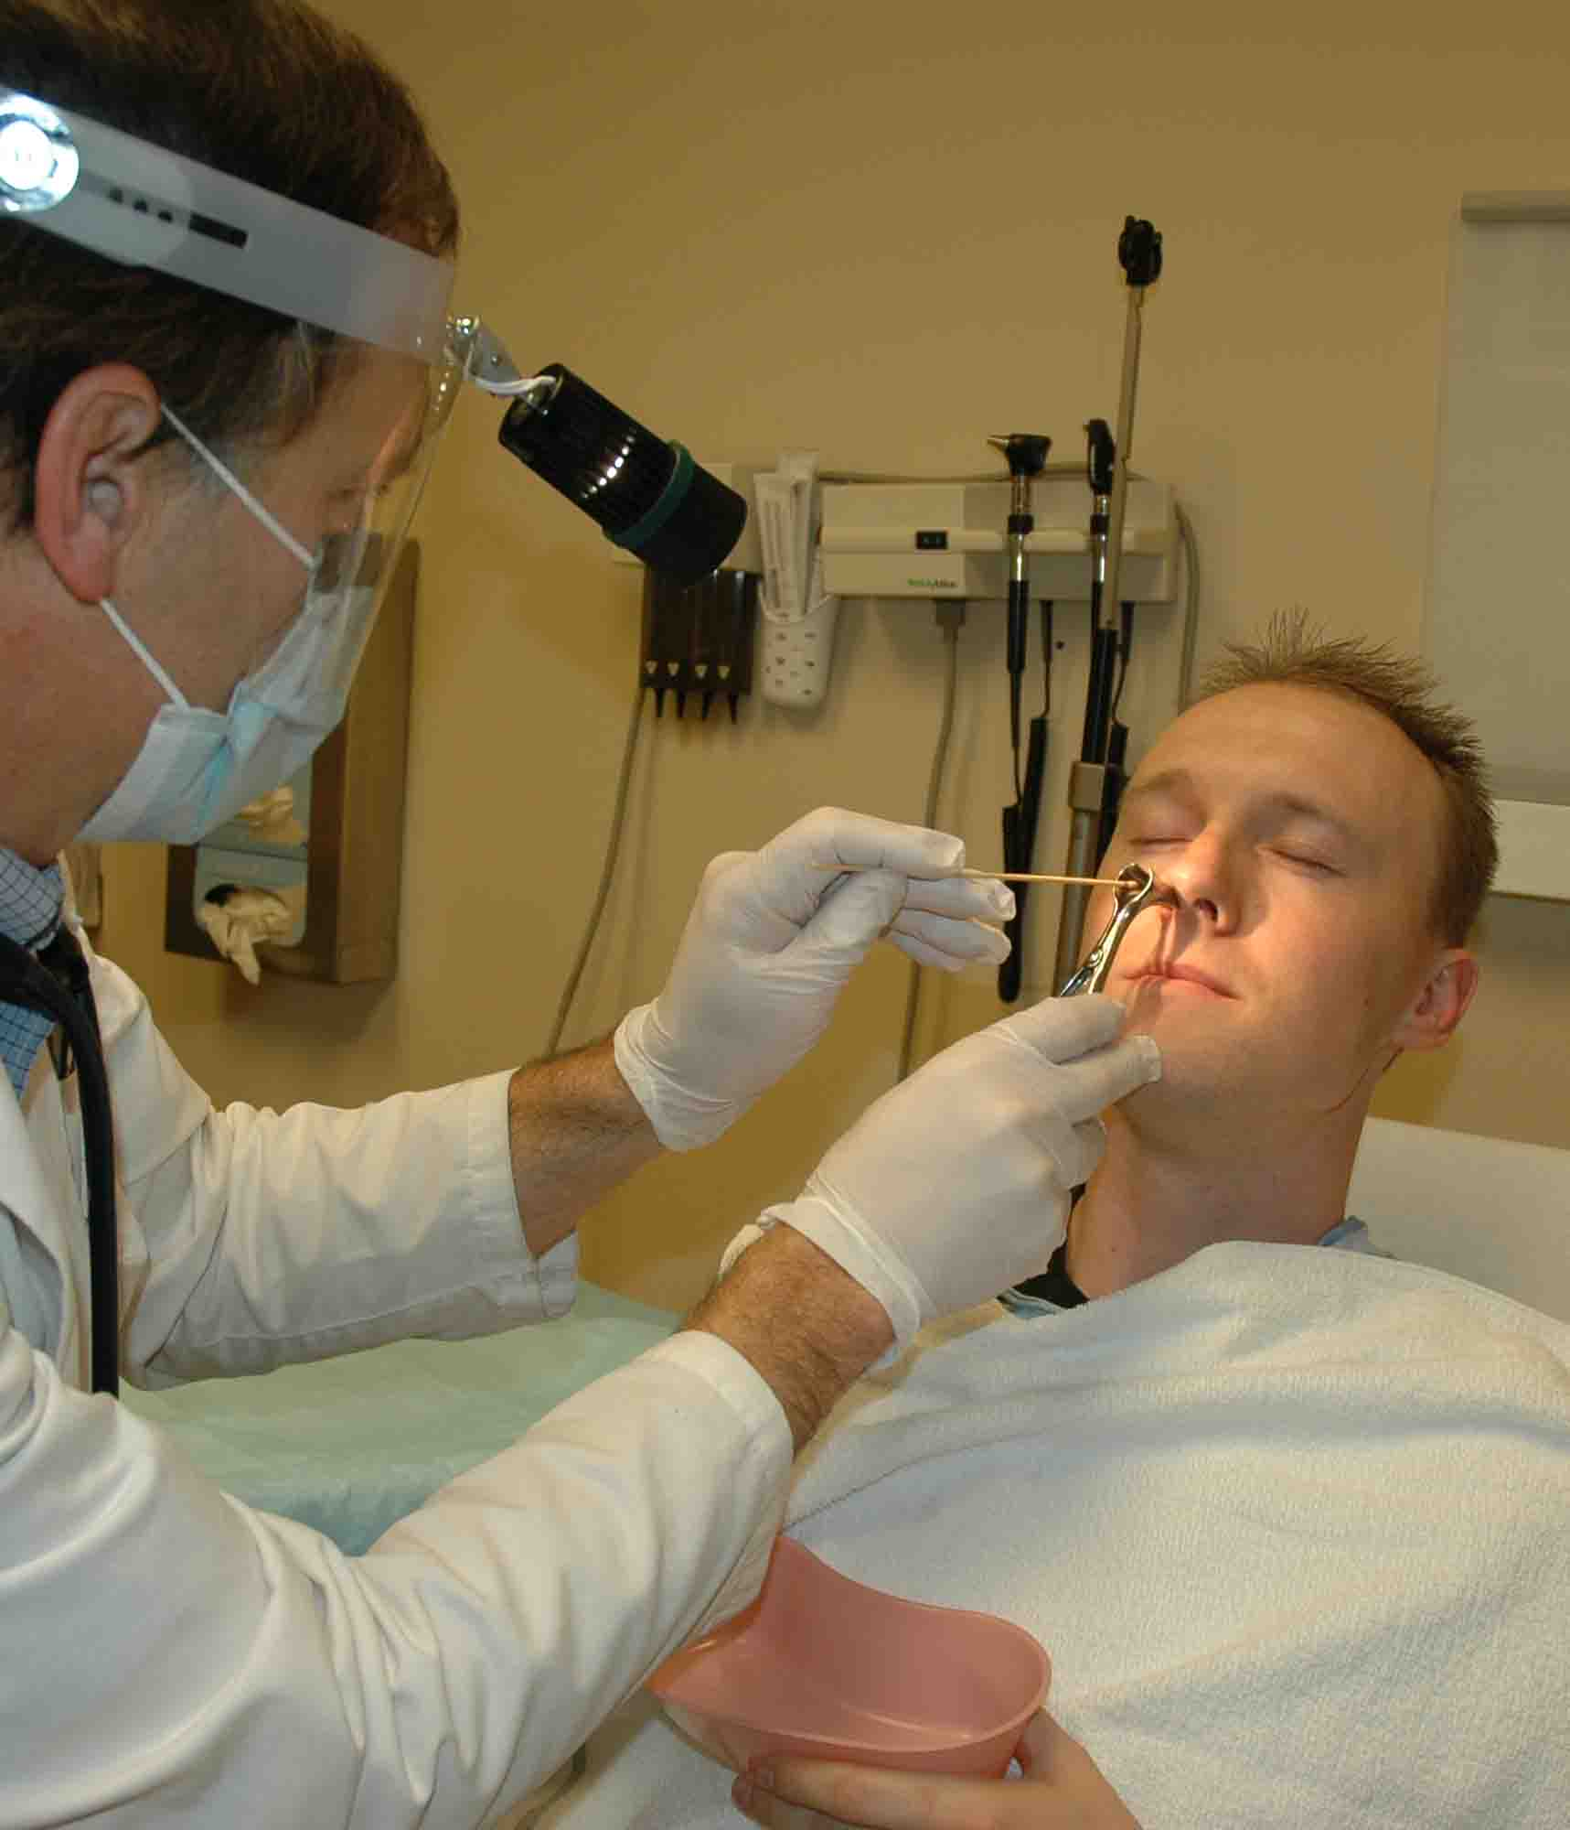
- If bleeding persists, obtain topical thrombin and repeat the above procedure using thrombin as the atomized spray and applying another cotton ball soaked in oxymetazoline - this gives clotting effect plus vasoconstriction.
- Discharge the patient with instructions to use oxymetazoline spray every 8 hours for the next 48-72 hours to maintain vasoconstriction. Forewarn them to not use the oxymetazoline for a longer period due to rebound edema problems. Instruct them to apply topical Vaseline or other appropriate material to the anterior nose twice a day to keep the mucous membrane from drying and cracking.

